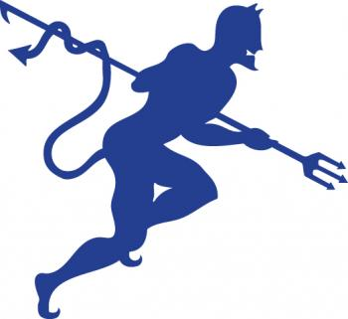**CELESTE YOUTH SPORTS ASSOCIATION SPONSOR CONTRIBUTION FORM**

# As a sponsor of the Celeste Youth Sports Association, I enclose my donation of $ _

SPONSOR LEVELS

# Grand Slam ($1,000)

* Recognition on Facebook
* Email with recognition to all registration email addresses
* Logo and recognition on CYSA Website Page
* Metal sign 2’ x 3’ (provided by CYSA) mounted on back stop fence for 2023 season

# Home Run ($300)

* $50 discount for previous sponsor with a banner in good condition
* Recognition on Facebook
* Logo and recognition on CYSA Website Page
* 2.5’ x 4' banner or sign (provided by CYSA) mounted on outfield fence for 2023 season

# Base Hit ($75)

* Sponsor name on individual 8 ½" x 11" sign on concession stand Wall of Fame for 2023 season

Name _ Address

Email_______________________________

Phone# __

Celeste Youth Sports Association is a non-profit 50l(C) organization. Donations are tax deductible.